ORDER OF WORSHIP
* Indicates, please stand if able.
Nineteenth Sunday after Pentecost October 8, 2023, 9 am
Liturgist: Dan Brauner

WELCOME, PASSING THE PEACE OF CHRIST, & ANNOUNCEMENTS
*CALL TO WORSHIP
L: Welcome to God’s house, a place of faith.
P: From our homes, we come seeking God’s word.
L: Here you will find nourishment and hope.
P: May we learn lessons of courage and peace.
L: Here you will find rest from your struggles
P: Lord, prepare our hearts to receive your words that we may leave this holy house of faith and return to our homes, encouraged and challenged to be your people. AMEN.
*OPENING PRAYER (Psalm 19, Philippians 3)
Holy Spirit, heavenly God, shine upon us with the wisdom of ancient words. Enlighten our minds, that we may perceive your presence. Strengthen our resolve, that we may press toward growth in love and faith. Help us grow closer to your likeness each and every day. Amen.
*OPENING HYMN Days of Elijah Worship and Song 3186
JOYS AND CONCERNS
PRAYER OF CONFESSION (Psalm 19, Philippians 3, Matthew 21)
God of grace and God of glory, bless us with your mercy and your steadfast love. When we pursue pointless gains and embark on dead-end journeys, guide us back to your ways. When we strive for our own righteousness, remind us that your righteousness is all we need. When we reject your teaching, or, even worse, reject your presence, love us and correct our ways. Forgive us and welcome us home into the arms of your grace and love. AMEN.
WORDS OF ASSURANCE (Exodus 20, Philippians 3)
Do not be afraid, God’s love is strong enough to overcome our weaknesses. Amen.
PASTORAL PRAYER Rev. Shon
THE LORD’S PRAYER (In Unison)
Our Father, who art in heaven, hallowed be thy name. Thy kingdom come, thy will be done on earth as it is in heaven. Give us this day our daily bread. And forgive us our trespasses, as we forgive those who trespass against us. And lead us not into temptation, but deliver us from evil. For thine is the kingdom, and the power, and the glory, forever. Amen.
INVITATION TO THE OFFERING (Psalm 105)
As we listen for the word of God, may our thoughts linger on what is honorable and true, just and pure, pleasing and commendable, excellent and worthy of praise.
*DOXOLOGY Praise God, from Whom All Blessings Flow UMH #95
*OFFERTORY PRAYER Rev. Shon
SCRIPTURE Ephesians 3:16-21
¹⁴ For this reason I kneel before the Father, ¹⁵ from whom every family^{[a]} in heaven and on earth derives its name. ¹⁶ I pray that out of his glorious riches he may strengthen you with power through his Spirit in your inner being, ¹⁷ so that Christ may dwell in your hearts through faith. And I pray that you, being rooted and established in love, ¹⁸ may have power, together with all the Lord’s holy people, to grasp how wide and long and high and deep is the love of Christ, ¹⁹ and to know this love that surpasses knowledge—that you may be filled to the measure of all the fullness of God.
²⁰ Now to him who is able to do immeasurably more than all we ask or imagine, according to his power that is at work within us, ²¹ to him be glory in the church and in Christ Jesus throughout all generations, for ever and ever! Amen.
*HYMN OF PRAISE Be Thou My Vision UMH #451
SERMON Why We Pray Together Rev. Shon
*CLOSING HYMN I’m Gonna Live So God Can Use Me TFWS # 2153
*BENEDICTION Rev. Shon

ANNOUNCEMENTS

PRAYER REQUESTS: Please pray for people in need in our church, community, nation,
and the World. The pastor’s shoulder surgery, Monday.
DYNAMITE PRAYER: Begins today for 28 days together. Pray together at church at
7 am -9 am. The book is available at the entrance desk. A free-will donation is appreciated.
BREAKFAST: Pancake breakfast served by Youth after worship service.
MISSIONARY VISIT: Temba Nkomozepi, Mujila Falls Agriculture Center Missionary in
Zambia on Wednesday, Nov. 1, at 5 pm
WEDNESDAY CONNECTIONS: VOLUNTEERS NEEDED for meal service at 5 pm.
BIBLE STUDY: “Living as United Methodist Christians” Sunday, 10:30 am at Keefe Room.
BIBLE STUDY: “Invitation to the Old Testament.” Thursday, 7:00 pm in the library.
SCRIP CARDS: When you are thinking of ideas for gift-giving or personal use, consider
Scrip cards. Stop at the gathering area on Sundays or call Marcia at 715-284-3346
USHER/GREETERS: Luane Myer/Roxie Hostrawser
FELLOWSHIP: Katrina Pierce

MEETINGS
Sun Oct. 8 Small Group Plan 10:30 am
Mon Oct. 9 Trustees 5:00 pm
Tue Oct. 10 Worship/Ad Council 5:30 pm/6:30 pm
Wed Oct. 11 Youth/Confirmation Class 5:30 pm/7 pm

Bible Verse of the Week: Psalm 32:8 (New International Version)
“I will instruct you and teach you in the way you should go;
I will counsel you with my loving eye on you.”

Bible Trivia of the week:
Which disciple was a physician?
A. Luke B. Thaddaeus C. Bartholomew D. James
See: Colossians 4:14

Black River Falls
United Methodist Church

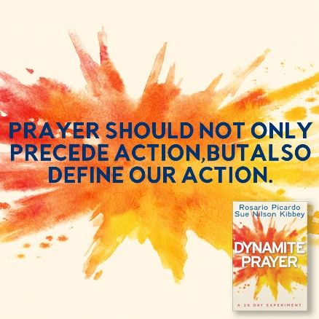

UMC Mission Statement:
"To make disciples of Jesus Christ for the transformation of the world.”

PASTOR Rev. Inwha Shon

100 North Fourth Street, Black River Falls, WI. 54615
Phone: 715-284-4114 Office Hours: Monday-Thursday, 9 am-2 pm
Website: brfumc.org
Facebook: Black River Falls United Methodist Church
YouTube: brfumc

